1. First step, database ***companydatabase*** and collections ***trabajador*** and ***edificio*** are created.

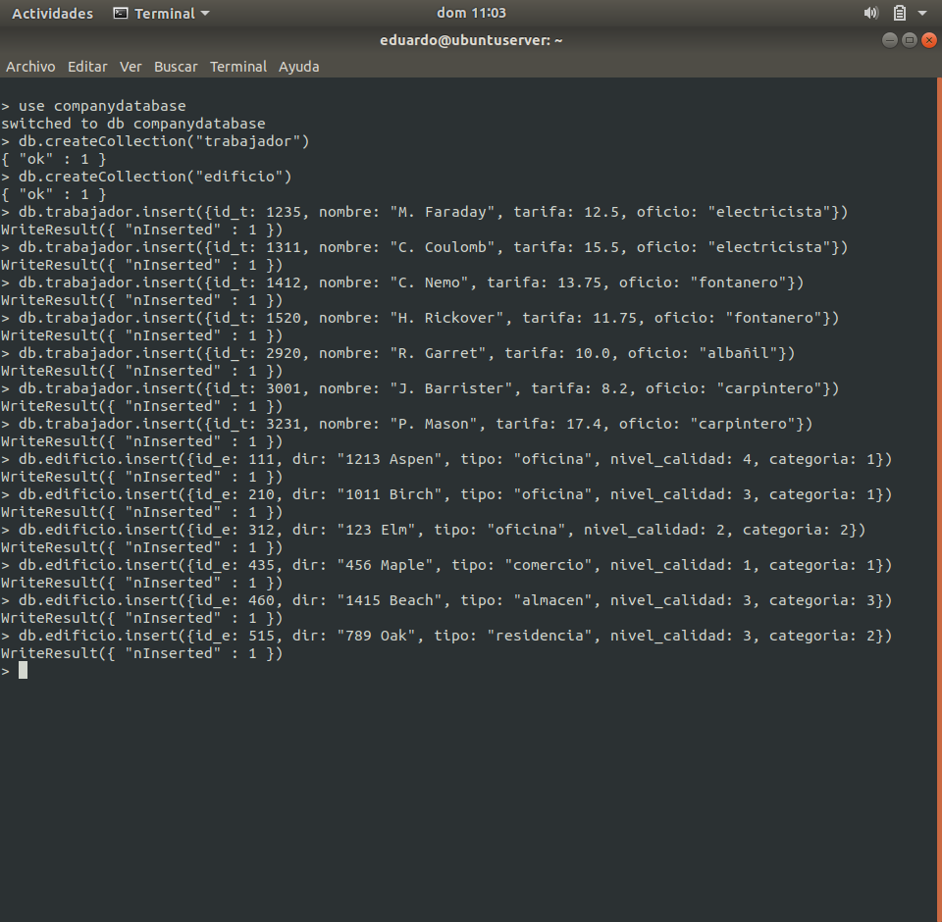

1. Then, some records with the columns ***id_t***, ***nombre***, ***tarifa*** and ***oficio*** are inserted in database ***trabajador***.



1. Also, some records with the columns ***id_e***, ***dir***, ***tipo***, ***nivel_calidad*** and ***categoria*** are inserted in database ***edificio***.



1. Now, let’s do to make some queries:

* Show the name of the workers.

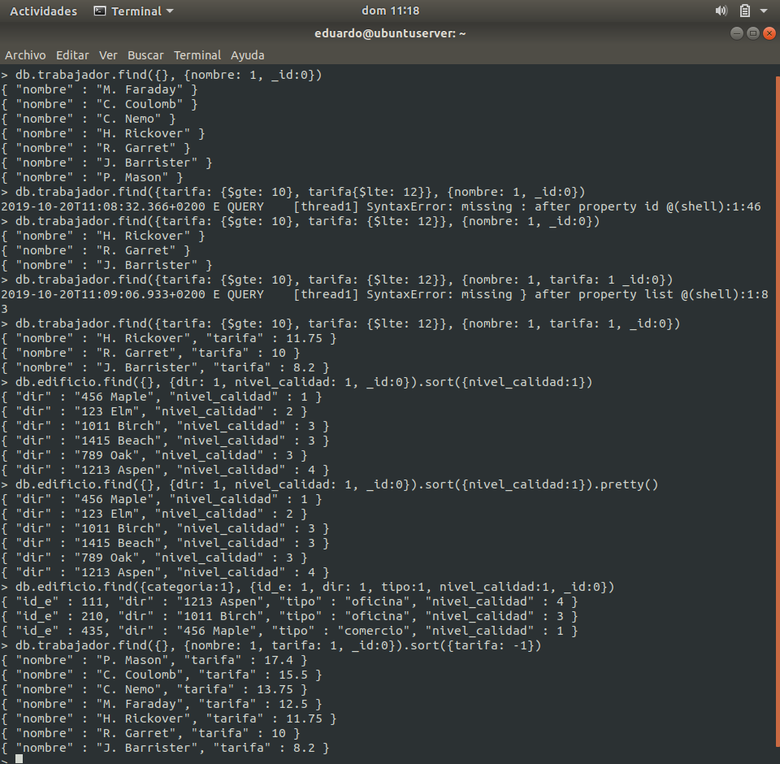

* Show the name of the workers where ***tarifa*** is between 10 and 12.



* Show the address of the buildings ordered by ***nivel_calidad***.



* Show the buildings with level 1 of ***categoria***.



* Show the name of the workers ordered by ***tarifa*** form maximum to minimum.

